10.67: For the disk, 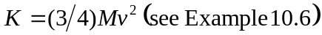. From the work-energy theorem, 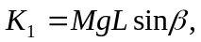 from which

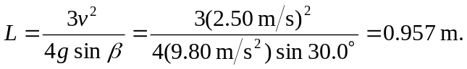

This same result may be obtained by an extension of the result of Exercise 10.26; for the disk, the acceleration is 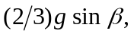 leading to the same result.
b) Both the translational and rotational kinetic energy depend on the mass which cancels the mass dependence of the gravitational potential energy. Also, the moment of inertia is proportional to the square of the radius, which cancels the inverse dependence of the angular speed on the radius.

